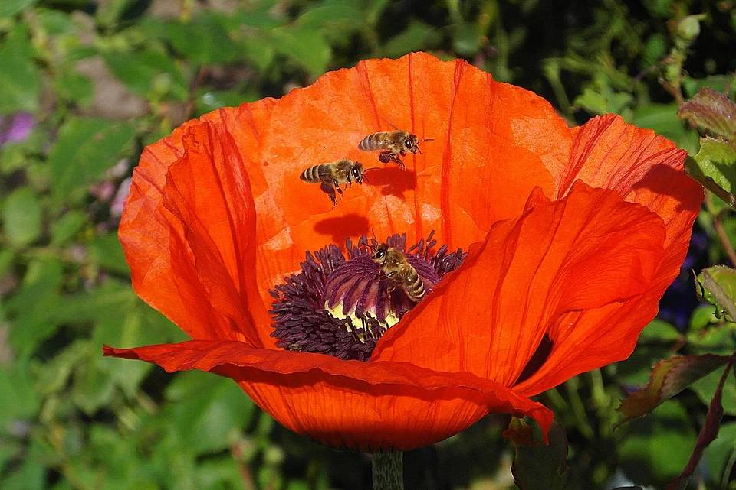

Eatontown Pollinator Garden Challenge
The borough of Eatontown is having a pollinator garden challenge.
All Eatontown residents are eligible to participate.
Participation in the challenge is simple. Just send an email to eatontown_pollinator@outlook.com, indicating that you intend to participate (along with your address). At the end of the summer, send a photo of your pollinator garden and list of plants to the email noted above.
Depending on participation level and interest, there may be additional activities such as plant swaps and garden tours.
If don’t have space for a garden at your residence, you can get a plot at the Eatontown community garden for a relatively small fee. To download the registration form, go to
http://eatontownnj.com/community-garden-advisory-committee/
General information about pollinator gardens can be found at
https://github.com/sfratini33/eatontown-pollinator-gardens/wiki.

